Access to Syllabi on LIS School Websites
Richard J. Cox, with the assistance of Joel A. Blanco
December 1, 2006

Introduction

This brief report considers online access of course syllabi from twenty-five Library and Information Science schools, selected from the American Library Association directory. Two main questions were considered:
1. Does the website offer public access to course syllabi?
2. How can users access the syllabi?
Some recommendations on how the School of Information Sciences can improve the online access of course syllabi are made at the conclusion.
Results from the Websites

From the twenty-five websites examined, eighteen offer open access to some or all of the current course syllabi. Five offer open access to all current course syllabi (University of North Carolina – Chapel Hill, University of Alberta, Dalhousie University, University of Kentucky, and Dominican University). Some schools offer only a modest selection of course syllabi, such as two, three, and four syllabi. For example, the Graduate School of Library and Information Sciences at Simmons College has a course catalog with a brief description of each course and a link to a pdf document with more detailed descriptions, but provides access to only two full syllabi found on faculty websites.
Open access to syllabi is usually found in two ways, from a courses section at the school’s website or via faculty personal websites. The majority of syllabi accessed from the schools reveal no uniformity. For example, the University of Kentucky School of Library and Information Science includes a section with the list of all the courses (http://www.uky.edu/CIS/SLIS/syllabi.htm), and each course has a link to a syllabus. However, each course has more than one link for each professor that has taught the class. A user cannot know which one is the most current until accessing the syllabus. In addition, syllabus can be found either in pdf or html format.
Many LIS programs, like the one at the University of Illinois at Urbana-Champaign, only allow access to syllabus trough a Course Management System. Urbana uses GSLIS Moodle, and although it allows “guest” users, in order to access a course website or syllabus the users needs to ask the professor for an “enrollment key.”
None of the schools’ websites provide any sort of disclaimer or general information regarding copyright or use of the syllabi. Having syllabi available online can result in professors from other programs copying a syllabus for their own courses. Whether this is an issue or not may vary among individual faculty members or may only be an issue if someone passes off a course syllabus as their own work (especially as part of a tenure and promotion case). Such issues may be minimized by the advantages to our own students and us in having easier access to syllabi and the potential of the positive aspects for recruiting students and marketing the various SIS programs.
Examples

University of North Carolina (http://sils.unc.edu/)
The website includes a section on course schedules which offers a link to the schedules for Summer 2006, Fall 2006 and Spring 2007. In addition to the schedule, for each course there’s a link for the course description, instructor’s information, and class syllabus if available (see Appendix A). In sum, the user does not need to move from page to page, or go to faculty personal pages, to access the main information for each class.
University of Alberta (http://www.slis.ualberta.ca/)
Access to syllabus can be made through the “Courses” section. Users can access the course listing by area of interest or by course number. There’s a brief description and a link to the course syllabus. Each syllabus is published using basically the same structure, an html page with the menu of the various sections of the syllabus at the left side of the page (see Appendix B).
University of Arizona (http://www.sir.arizona.edu/)
In addition of allowing access to current course syllabi, users can also see a syllabus from as early as 1995 through the “Syllabus Archive” section. Users can search by course number or title, instructor or semester (see Appendix C). Not all links for past syllabus works, but it is very interesting to see the school’s desire to document the development of the syllabi through the years.
Recommendations

The University of Pittsburgh School of Information Sciences currently presents course descriptions online (http://www.sis.pitt.edu/academics/courses/07_1/071lis.html). Some of the syllabi can be accessed without restriction from faculty personal websites. For example, for the Fall 2006 term course schedule, only six syllabi are available online to the public (four are available from Richard Cox’s personal website).
There should be open access of syllabi on the web. By doing this the school could reach a broader audience, such as prospective students. It offers them a better idea about what specifically is taught at the school. Courses descriptions are so general that they really don’t offer enough information to compare with other schools. The co-author of this report, Joel Blanco, when analyzing prospective doctoral programs, examined syllabi on Dr. Cox’s website, discovering course topics and references matching his research interests.
There are other reasons for providing syllabi online. Publishing syllabus online also enables faculty to demonstrate the currency of their courses to current and prospective students. Having syllabi online also will facilitate our own advising, enabling easy examination of course content and requirements. And, by providing free and easy access to course syllabi, we can lead other LIS and I-Schools in offering fuller access to the knowledge held by our faculty.
What should we do? One option can be to link the syllabus of each course on the course schedule section, similar to what is done at the University of North Carolina. The other option is to create a specific page for the access of syllabi. This site can include course description, current syllabus, and an archive of past syllabi. The page should include general information regarding the use of the syllabi, like copyright, and who to contact for questions. And we should be uniform in how we publish the syllabi online, using one format (ex. pdf or html).
Appendix A: University of North Carolina – Chapel Hill
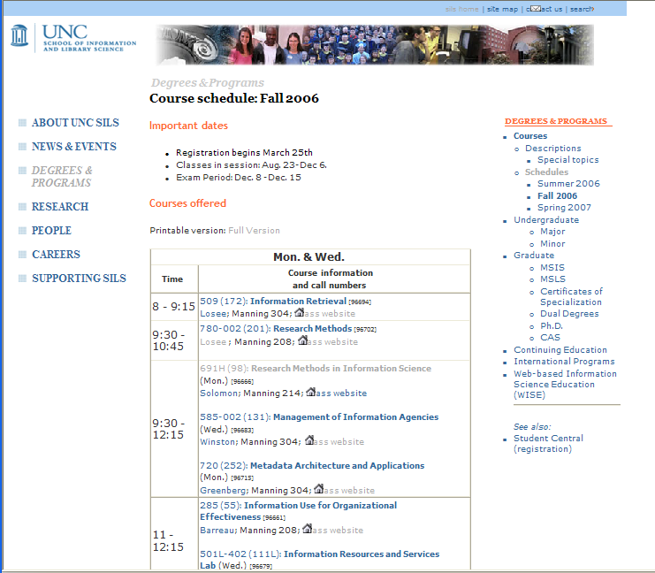

Appendix B: University of Alberta
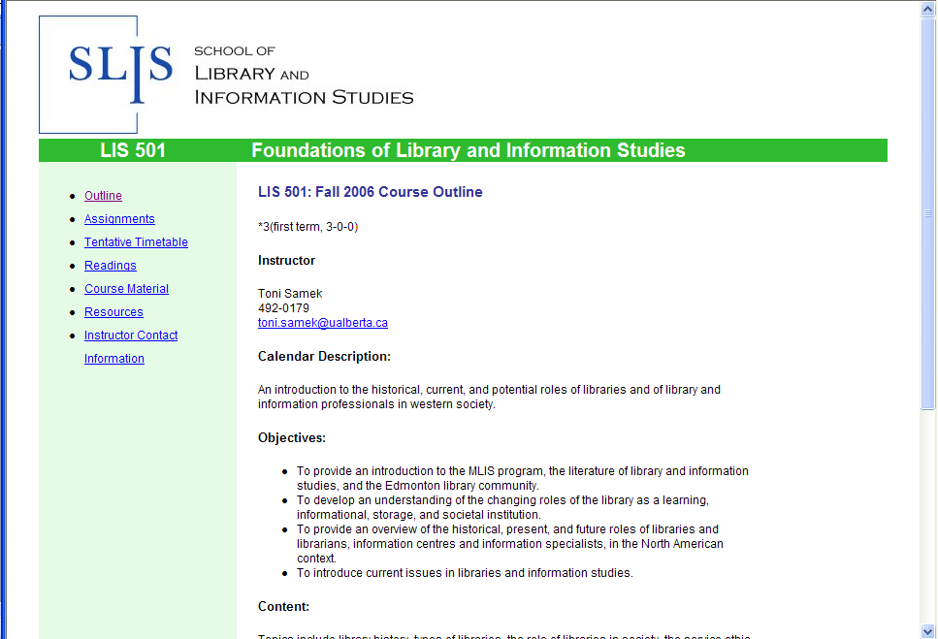

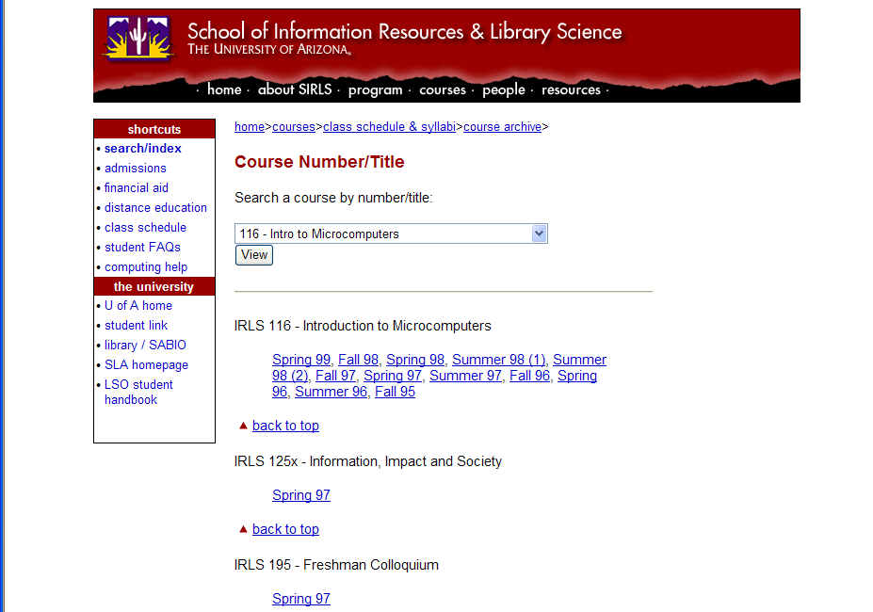
Appendix C: University of Arizona Syllabus Archive

An example can be found on the following link: http://courses.lis.uiuc.edu/course/enrol.php?id=20
http://sils.unc.edu/programs/courses/schedules.html
http://www.slis.ualberta.ca/courses.htm
http://www.sir.arizona.edu/courses/archive.html
Also from the website for the Fall course schedule links to six of the faculty members are not working.

